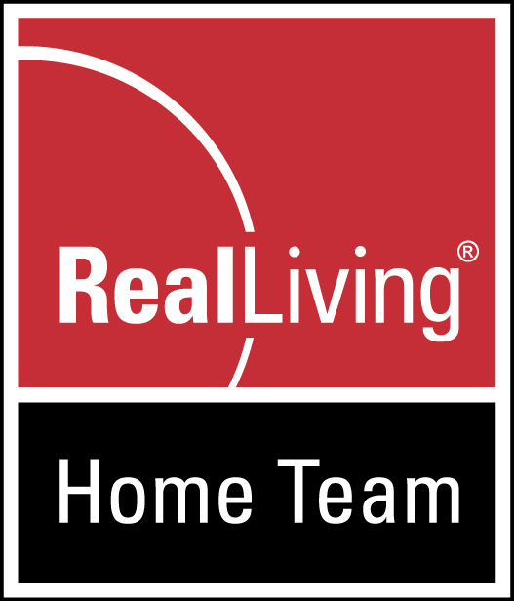
Real Living Home Team
www.YourRegionalRealtor.com

740-485-1641

OUR STORY

Real Living Home Team was founded in the fall of 2006 as Dave Culbertson and his family purchased the franchise rights to Real Living and formed Home Team Knox County LLC., doing business as Real Living Home Team. Since day one, we have strived to be a full-service real estate company serving the needs of clients in Knox County and the surrounding area. Dave has since grown his coverage area, as a Regional Realtor, serving about a dozen counties throughout Central and North Central Ohio.
Real Living Home Team has as its mission statement:
To provide honest and extraordinary service to our clients, create and maintain an exciting, fun and productive workplace for our agents and support staff, and to be a good corporate citizen of the community.
At Real Living Home Team, we recruit, train and coach only high-quality people to always be at the forefront of customer service, marketing and technology. We also have an excellent support staff and systems to assist our agents and to help keep communications and feedback flowing to and from our clients, agents, other REALTORS, and the community as a whole. When you hire one member of the team, you get the support of the whole team. And you don’t just get realtors, you get a top-notch Advertising Agency and Marketing Department. We also “give back” to the communities that support us, in a variety of ways.
Different from some area real estate offices, Real Living Home Team believes it is important to expose its listings to as many REALTORS as possible. To accomplish this, we are members multiple MLS Services, to reach out further. We are also proud to be part of the Real Living Network of offices, covering the State of Ohio, giving us the ultimate in state-wide coverage for our listings. We are also in 42 states, coast-to-coast and growing. This gives you, the seller, the best opportunity to sell your home, by reaching more agents, who will in turn, let their buyers know about your home…”casting the net out far and wide,” as possible, to better serve our clients. This is important because in today’s market, you never know where your buyer might come from.

Another major part of our marketing is internet marketing, quality photography and an impressive web presence. Our listings can be found on 100+ internet portals world-wide…as well as taking advantage of many of the social networking platforms.
We are located in Mount Vernon, but we’re more than a Mount Vernon real estate office. We are an advertising and marketing company with regional, state-wide and national coverage.
REAL LIVING’S GROWTH NATIONWIDE…WORLD WIDE

Real Living is a vibrant, exciting network of real estate professionals that is growing nationwide at a rapid pace. The company was formed in 2002 with a vision and plan to serve real estate clients like no other company. Since then, Real Living Merged with the nationwide mega-franchises, GMAC Real Estate and Prudential Real Estate, for even more coverage. And most recently, the Real Living Network has been acquired by Warren Buffet’s Berkshire Hathaway Real Estate Services. If Warren Buffet believes in our company and in residential real estate…we believe you should too. Being part of the Berkshire Hathaway Network, we now have a HUGE amount of backing to grow our company even more. Watch for exciting things ahead for Real Living! Our market share of SOLD homes is growing year after year…we must be doing something right!

Again, we are a LOCALLY-OWNED franchise under the umbrella of Real Living and Berkshire Hathaway. We are dedicated to having our agents be the best-trained Realtors in our market as well as dedicated to being good corporate citizens of Knox and surrounding counties. Our website now features 1000’s of homes throughout Ohio.

It would be our pleasure serving YOU!

